Lamin Sanneh (1942-2019)

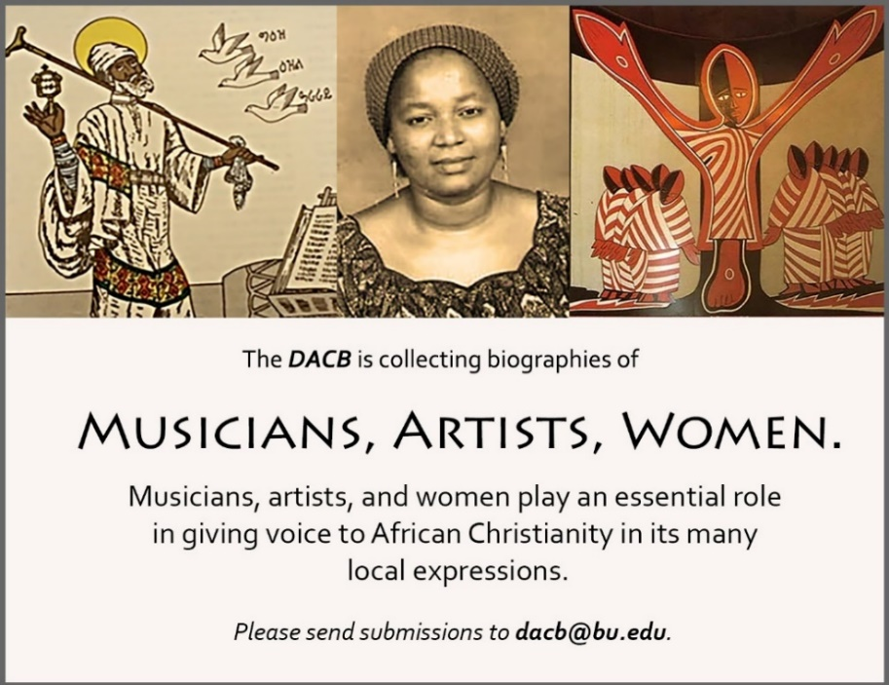

Subscribe to the JACB at www.dacb.org/news/journal/
Journal of  African  Christian  Biography | Vol. 4, No. 2 (April 2019)  Focus:  The Life and Legacy of Lamin Sanneh  (The Gambia)
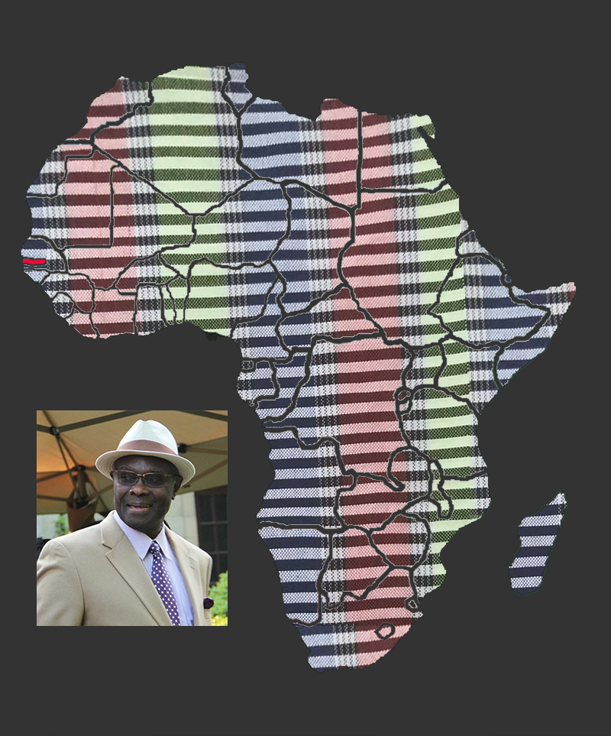
A publication of the Dictionary of African Christian Biography

