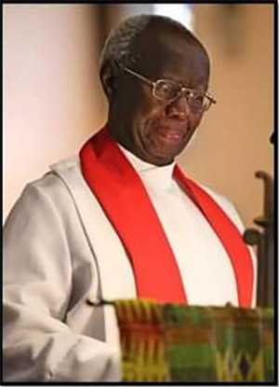
John S. Mbiti, 1931 - 2019

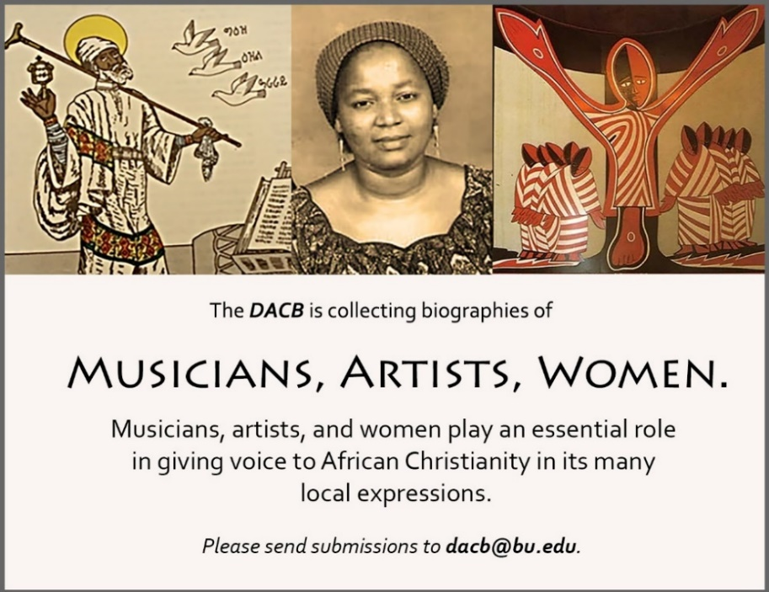

Subscribe to the JACB at www.dacb.org/news/journal/
Journal of  African  Christian  Biography | Vol. 4, No. 4 (Oct. 2019)  BILINGUAL ISSUE - Focus:  John Mbiti Tribute (Kenya)  Edward Francis Small (The Gambia)  Englebert Mveng (Cameroon) [in French]
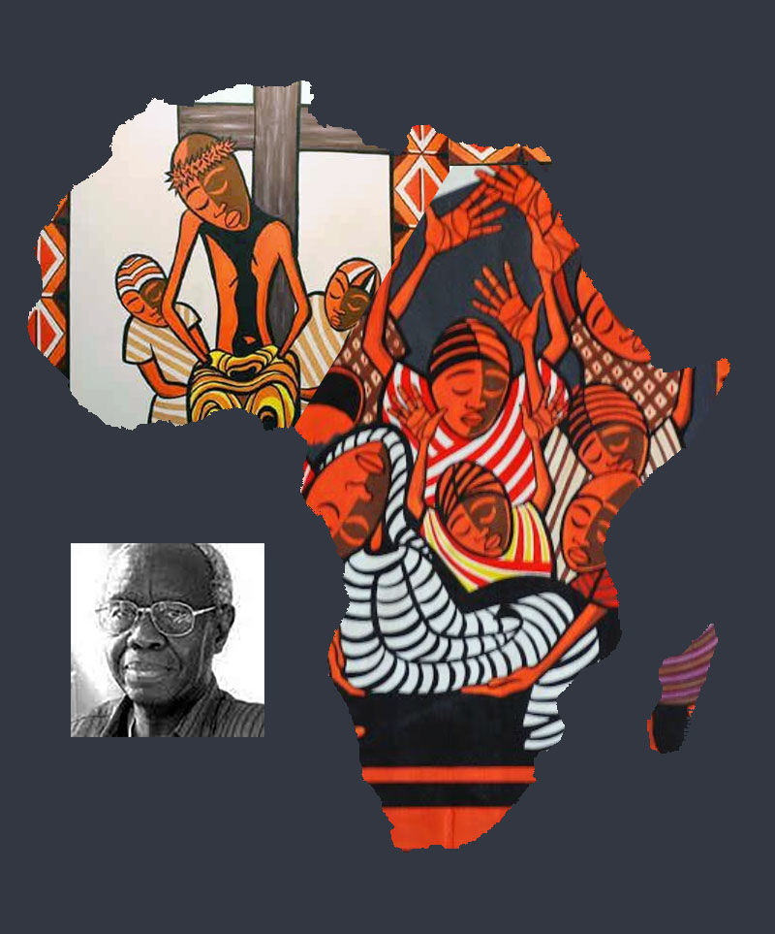
A publication of the Dictionary of African Christian Biography

