Afua Kuma. Watercolor painting (March 2018) by Professor Mark Shaw, Africa International University, Nairobi, Kenya.
Oral Theologian
Madam Afua Kuma
(1908-1987)
of Ghana
Jesus of the Deep Forest: Prayer and Praises of Afua Kuma

Journal of  African  Christian  Biography | Vol. 5, No. 3 (July 2020)  Focus:  C. Nyamiti (Tanzania), Afua Kuma (Ghana), E. Evans-Afom (Ghana), C. W. Tumi (Cameroon)
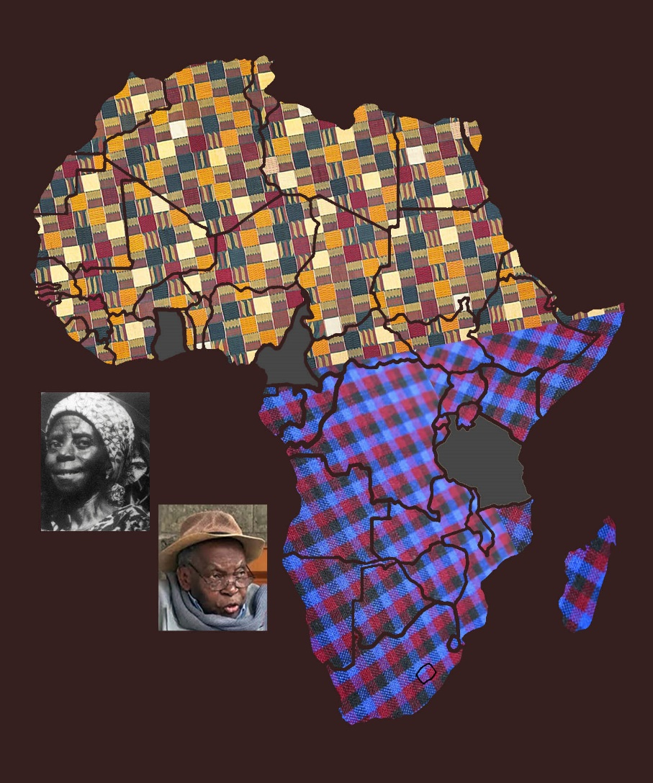
A publication of the Dictionary of African Christian Biography

