COVER PHOTOS: Jacob Modi Din as a prisoner of the colonial powers and Edward Mnganga (R. Pindzié), first Black Catholic priest of South Africa (G. Mukuka).

Journal of  African  Christian  Biography | Vol. 6, No. 3 (July 2021)  Focus: Project Luke Scholar  Biographies (1999-2011)  BILINGUAL ISSUE
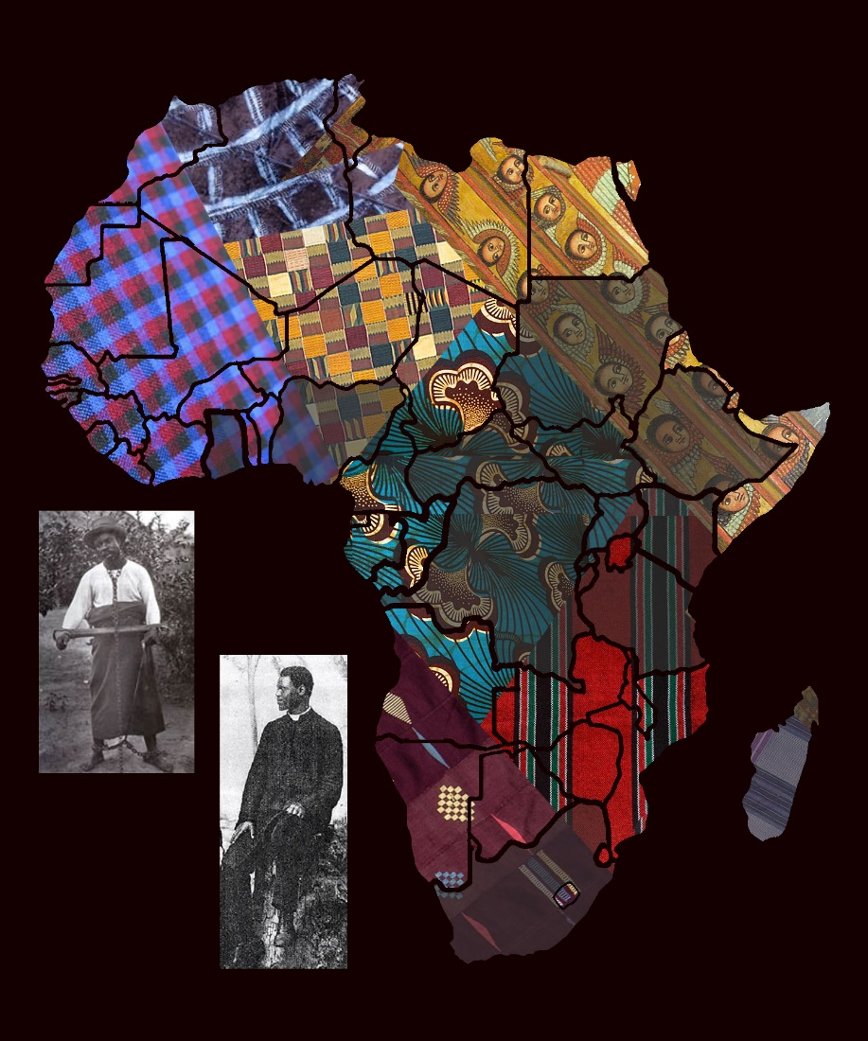
A publication of the Dictionary of African Christian Biography

