Journal of  African  Christian  Biography | Vol. 7, No. 1 (Jan. 2022)  Focus:  D. Tutu (S. Africa) and T. Tshibangu (DRC); D. Ayegboyin (Nigeria); Women’s stories (Kenya and Zimbabwe)
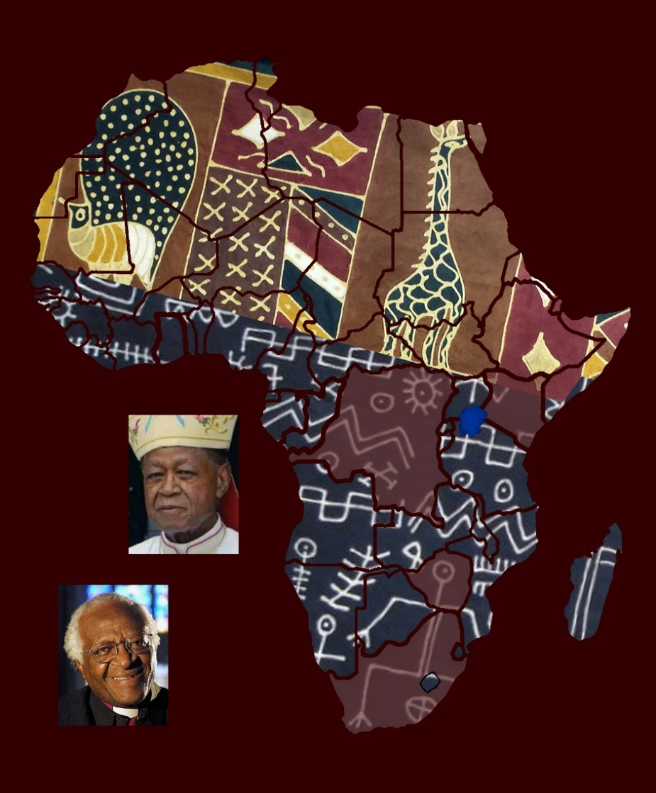
A publication of the Dictionary of African Christian Biography

