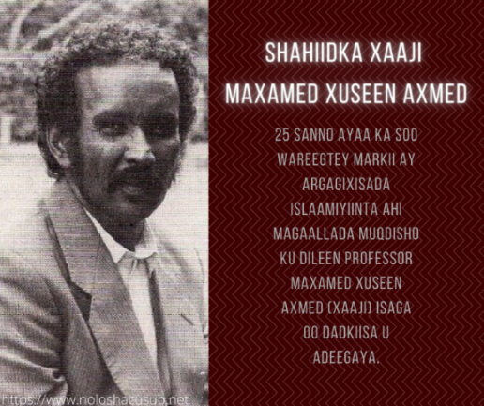 |  |  | 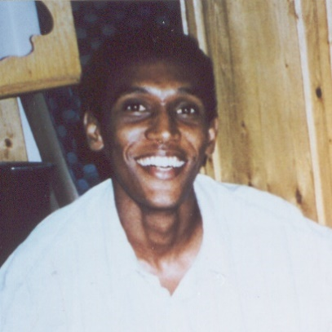
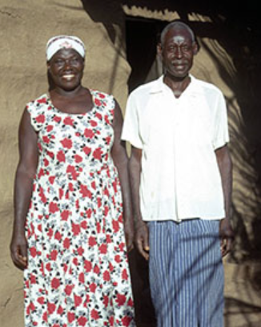 |  |  | 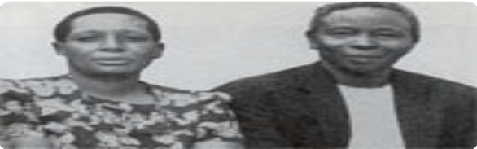  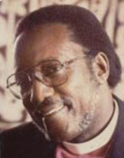
Clockwise from top left: “Xaaji” Maxamed Xuseen Axmed [Haji] (Somalia), Liibaan Ibraahim Xasan (Somalia), Eva and Simeoni Nsimbambi (Uganda), Festo Kivengere (Uganda), Tabitha Maria Magdalena Marwaale [and husband Xasan] (Somalia)
 | 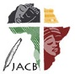 | Journal of African Christian Biography  Quarterly publication of the Dictionary of African Christian Biography  Sign up for a free subscription at https://dacb.org/journal/ |  | DONATE
Journal of  African  Christian  Biography | Vol. 8, No. 1 (Jan 2023)  Focus: East African Revivalists; T. Marwaale, L. Xasan, M. Xaaji (Somalia); BILINGUAL ISSUE: A. Zakariasy (Madagascar)
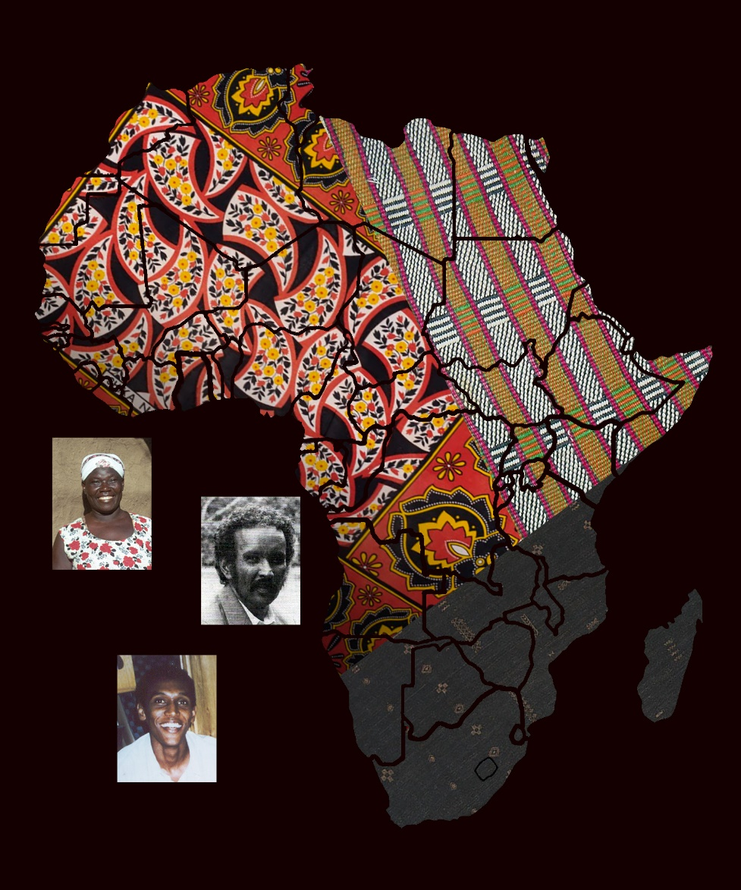
A publication of the Dictionary of African Christian Biography

