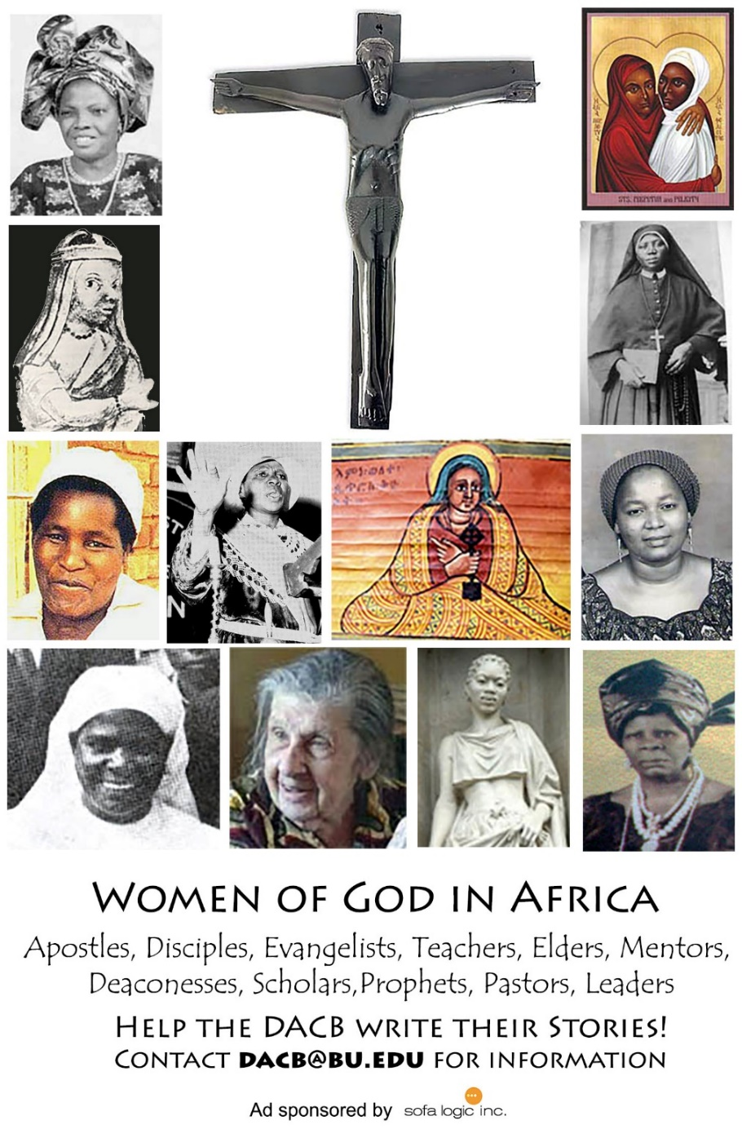

Journal of  African  Christian  Biography | Vol. 3, No. 3 (July 2018)  Focus:  Balya, Moshi, and Waliggo (E. Africa)  Wellington Mulwa (Kenya)  Interview with Jesse Mugambi (Kenya)
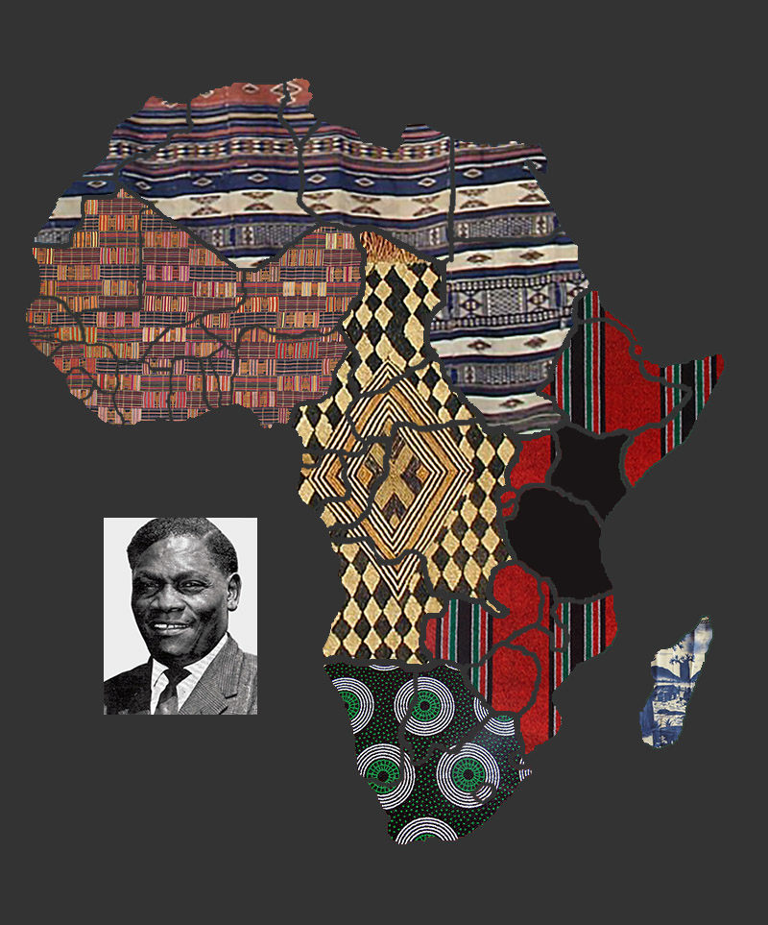
A publication of the Dictionary of African Christian Biography

