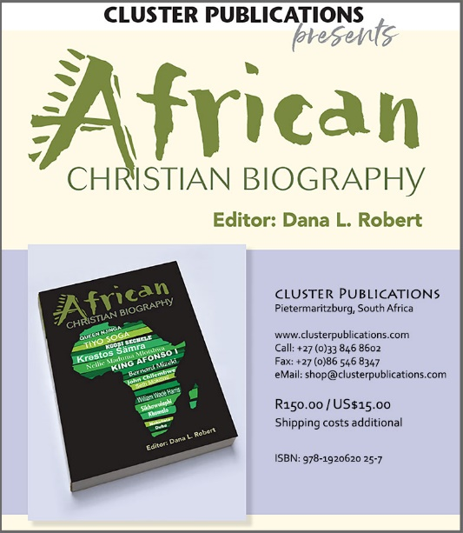

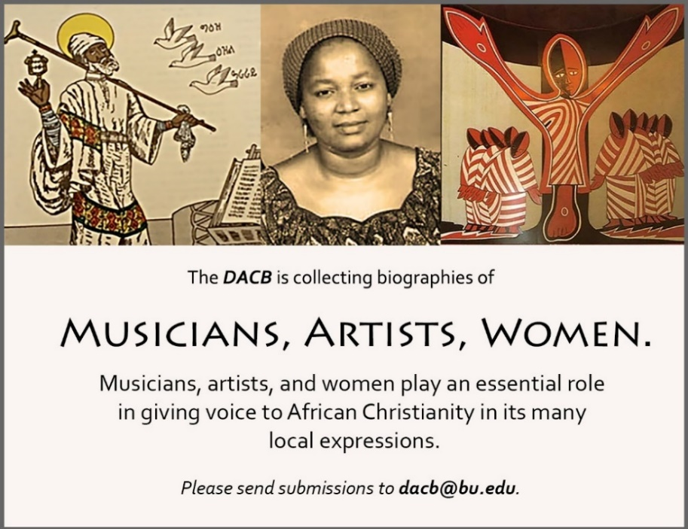

Subscribe to the JACB at www.dacb.org/journal/
Journal of  African  Christian  Biography | Vol. 5, No. 1 (Jan. 2020)  Focus: WOMEN  Kimpa Vita, Queen Njinga (Congo, DRC, Angola), Krəstos Śämra (Ethiopia)
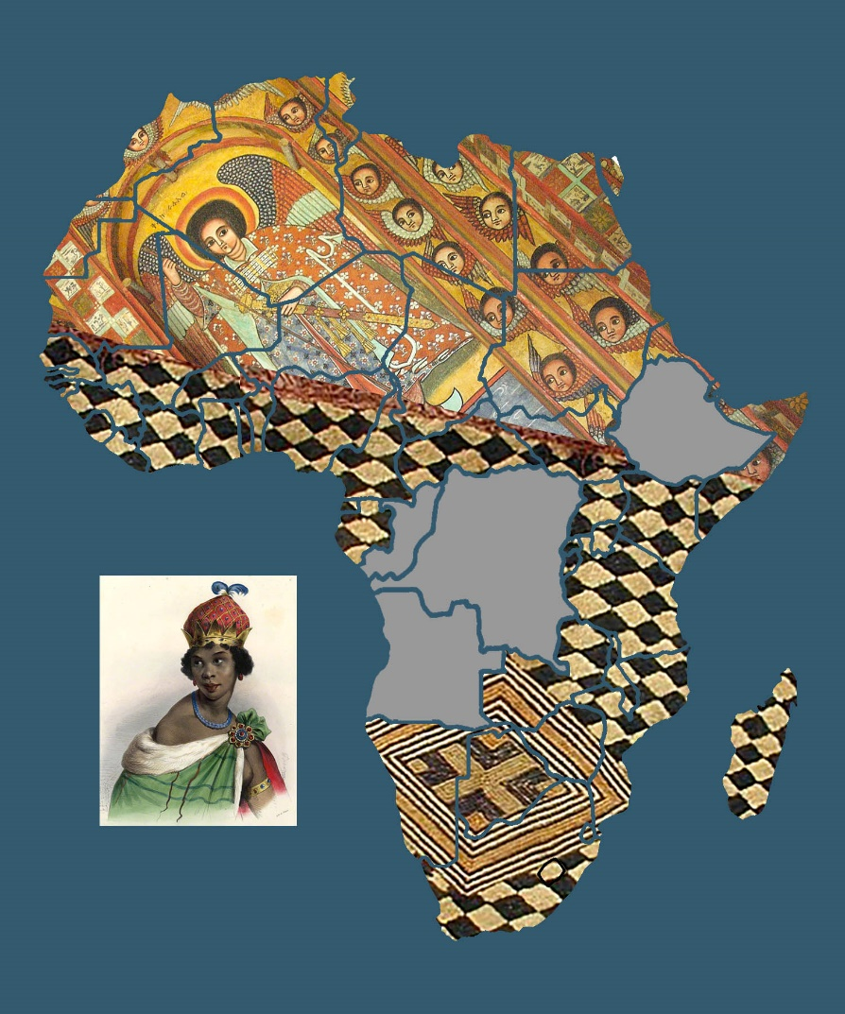
A publication of the Dictionary of African Christian Biography

