Honoring Jonathan Bonk, on his retirement
DACB Project Director 1995-2200 and JACB Editor 2016-2020

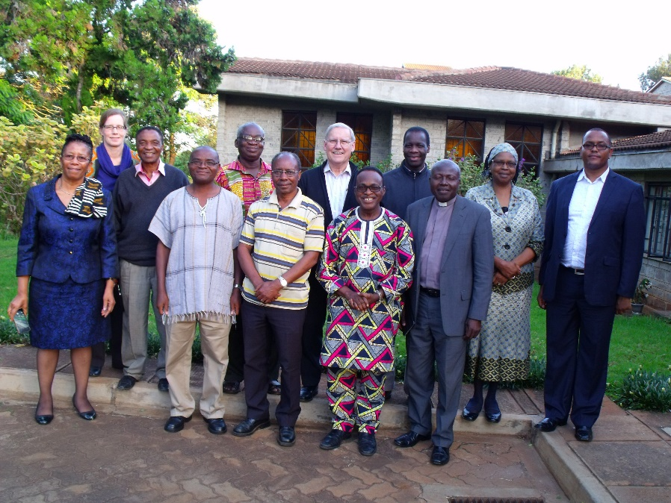
Executive-Advisory Committee Meeting, Nairobi, Kenya 2016
(From left to right) Madipoane Masenya (Ngwan’a Mphahlele), Michèle Sigg, James Amanze, Edison Kalengyo, Thomas Oduro, Jesse Mugambi, Jonathan Bonk, Deji Ayegboyin, Jean-Claude Loba Mkole, Gabriel Allen, Philomena Mwaura, Evangelos Thiani (missing: Paul Nkwi)

Journal of  African  Christian  Biography | Vol. 5, No. 4 (Oct 2020)  Focus:  Special Issue in Honor of  Project Director Jonathan Bonk
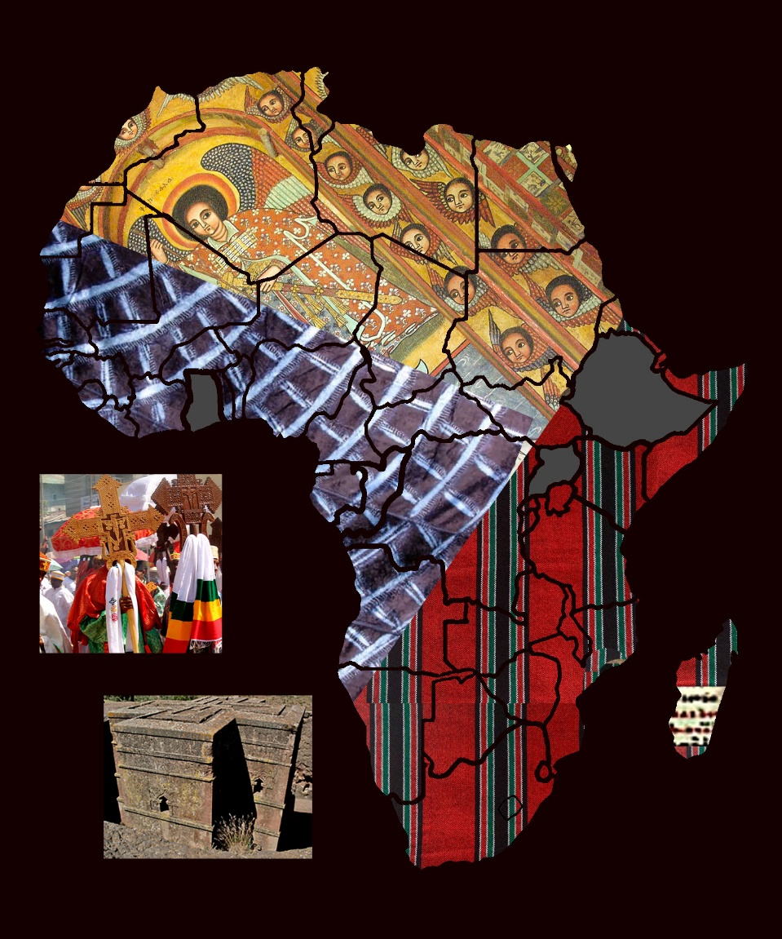
A publication of the Dictionary of African Christian Biography

