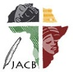 | Journal of African Christian Biography  Quarterly publication of the Dictionary of African Christian Biography  Sign up for a free subscription at https://dacb.org/journal/ | DONATE
Journal of  African  Christian  Biography | Vol. 7, No. 4 (Oct. 2022)  Focus: Pentecostal Movement  N. Bhengu (South Africa), B. Idahosa (Nigeria), E. Mrima (Kenya);  Laurenti Magesa (Tanzania)
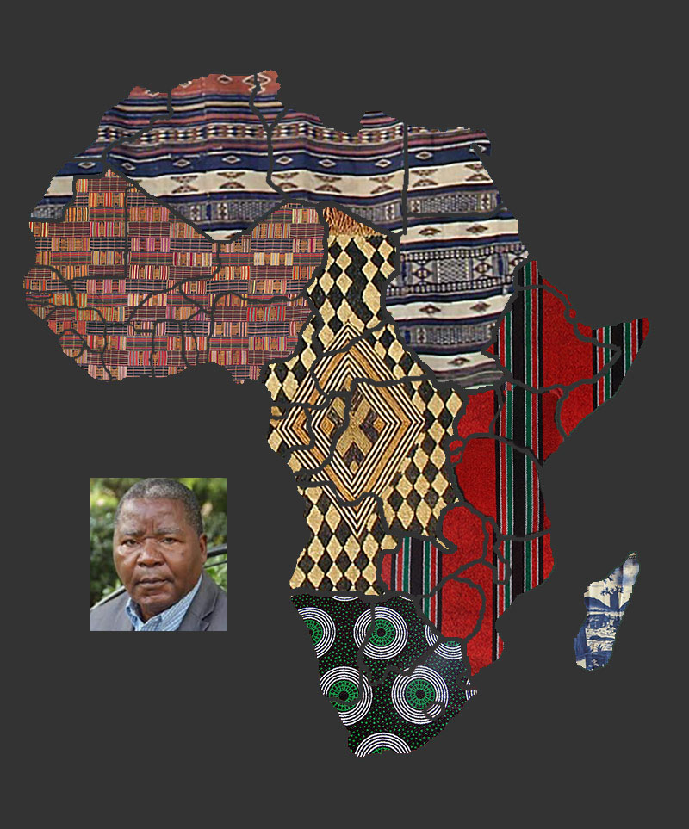
A publication of the Dictionary of African Christian Biography

