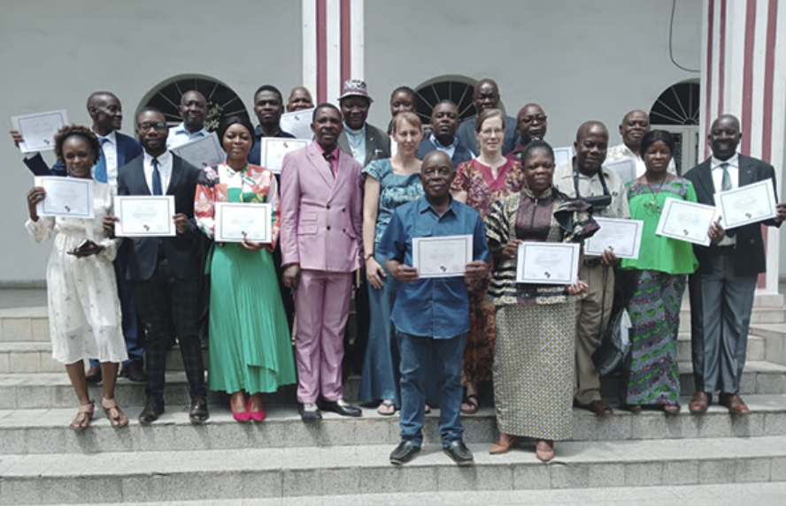
Atelier sur l’Ecriture de l’Histoire de l’Église / Church History Writing Workshop; 20-24 / 03 /2023, Kinshasa, DRC

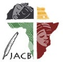 | Journal of African Christian Biography  Quarterly publication of the Dictionary of African Christian Biography  Sign up for a free subscription at https://dacb.org/journal/ | DONATE
Journal of  African  Christian  Biography | Vol. 8, No. 2 (April 2023)  Focus: A. Musopole (uMuntu Theology), I. Phiri, K. Fiedler (Malawi) [BILINGUAL] Workshop report/ Rapport de l’Atelier (DR Congo)
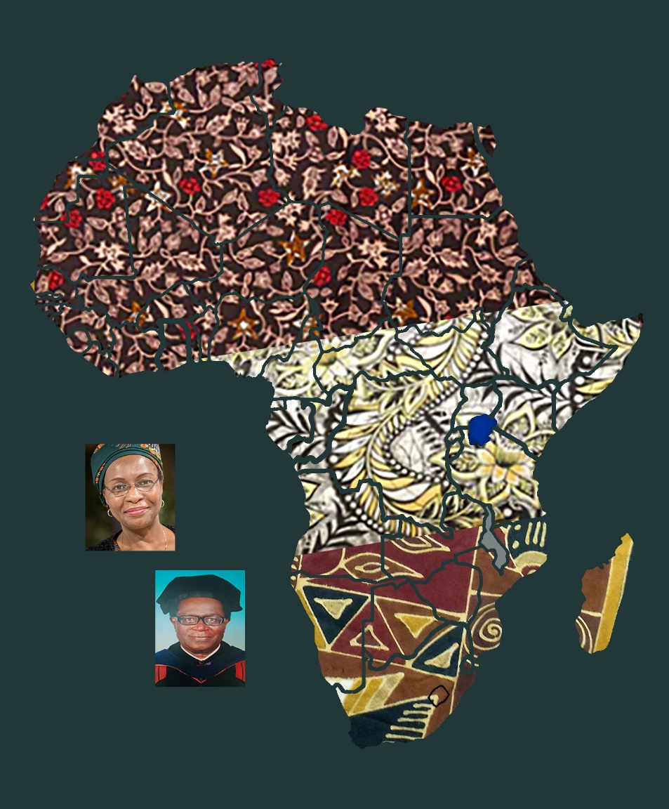
A publication of the Dictionary of African Christian Biography

